

***PMC-C-2***μ***m-7C***

***Hollow-Core Fiber optimized for 2-3µm range.***

**We tailor our hollow-core ﬁbers to your needs**

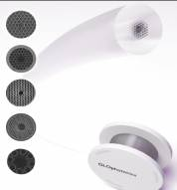

# Nearly single mode guidance

* *Low dispersion, low loss*
* *High power and energy handling\**
* *Broad spectral coverage*

## 

### Typical attenuation and dispersion

|  |  |
| --- | --- |
| ***Physical Properties*** | |
| *Core contour Hypocycloid with negative curvature parameter b>0.7\*\**  *Inner core*  *diameter 56 µm ± 1*  *Outer fiber diameter 415 µm ± 3%*  *Fiber coating layer Primary polymer coating* | |
| ***Optical Properties*** | |
| *Center wavelength* | *2000 nm* |
| *Attenuation @2000 nm* | *60 dB/km ± 5* |
| *Dispersion @2000 nm* | *1 ps/nm.km ± 0.5* |
| *Transmission band\*\**  *\*\*Attenuation lower than 150 dB/km* | *>350nm* |
| *Mode field diameter (1/e²)* | *42 µm ± 1* |
| *3 dB bend loss radius @1030 nm* | *5 cm ± 2* |

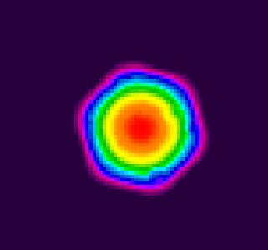 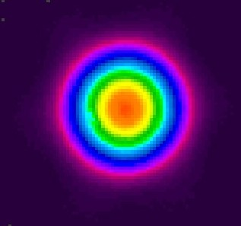

* See Opt. Express **22**, no. 9, 10735, 2014

** For b definition, see Opt. Exp. **21**, no. 23, 28597, 2013

### Output near field profile Output far field profile

All specifications may be changed without notice

*123 avenue Albert Thomas - 87060 Limoges Cedex France* [*www.glophotonics.fr*](http://www.glophotonics.fr/)[*contact@glophotonics.fr*](mailto:contact@glophotonics.fr)