

***PMC-C-Er-7C***

***Hollow-Core Fiber optimized for 1550nm. Ideal For Erbium lasers.***

**We tailor our hollow-core ﬁbers to your needs**

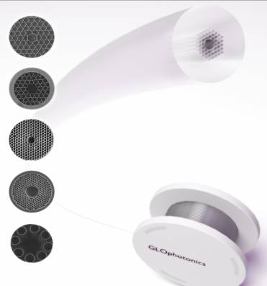

# Nearly single mode guidance

* *Low dispersion, low loss*
* *High power and energy handling\**
* *Broad spectral coverage*

## 

### Typical attenuation and dispersion

|  |  |
| --- | --- |
| ***Physical Properties*** | |
| *Core contour Hypocycloid with negative curvature parameter b=0.8\*\**  *Inner Core*  *Diameter 61 µm ± 1*  *Outer Fiber Diameter 435 µm ± 3%*  *Fiber Coating Layer Primary polymer coating* | |
| ***Optical Properties*** | |
| *Center Wavelength* | *1550nm* |
| *Attenuation 1550 nm* | *<50 dB/km* |
| *Dispersion @ 1550 nm* | *1 ps/nm.km ± 0.5* |
| *Transmission band\*\**  *\*Attenuation lower than 100 dB/km*  *for the 1375-1750nm* | *400 nm* |
| *Mode Field Diameter (1/e²)* | *42 µm ± 1* |
| *3 dB bend loss radius* | *5 cm ± 2* |

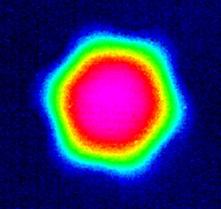 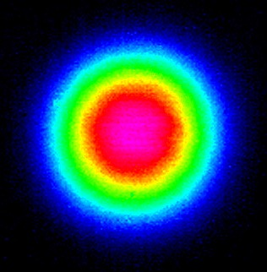

*\* See CLEO* ***STh4L.7****, 2015*

** For b definition, see Opt. Exp. **21**, no. 23, 28597, 2013

### Output near field profile

*Output far field profile*

All specifications may be changed without notice

*123 avenue Albert Thomas - 87060 Limoges Cedex France* [*www.glophotonics.fr*](http://www.glophotonics.fr/)[*contact@glophotonics.fr*](mailto:contact@glophotonics.fr)