

***PMC-C-Yb-7C***

***Hollow-Core Fiber optimized for 900-1100nm range. Ideal For Yb and Nd:YAG based lasers.***

**We tailor our hollow-core ﬁbers to your needs**

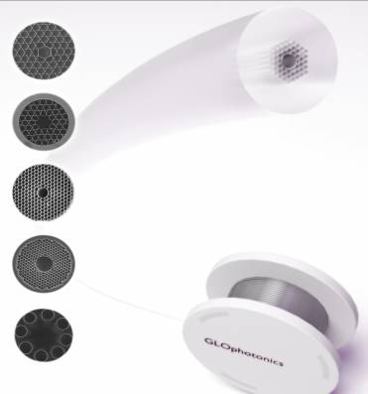

# Nearly single mode guidance

* *Low dispersion, low loss*
* *High power and energy handling\**
* *Broad spectral coverage*

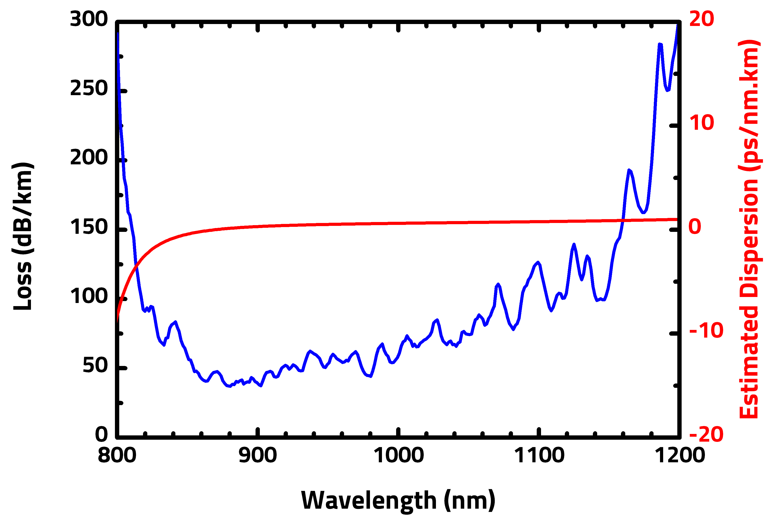

## Typical attenuation and dispersion

|  |  |  |
| --- | --- | --- |
| ***Physical Properties*** | | |
| *Core contour* | *Hypocycloid with negative curvature parameter b>0.7\*\** | |
| *Inner core diameter* | *57 µm ± 1* | |
| *Outer fiber diameter* | *320 µm ± 3%* | |
| *Fiber coating layer* | *Primary polymer coating* | |
|  | | |
| ***Optical Properties*** | | |
| *Center wavelength* | | *1030 nm* |
| *Attenuation @ 1030 nm* | | *<100 dB/km* |
| *Dispersion @1030 nm* | | *1 ps/nm.km ± 0.5* |
| *Transmission band\*\**  *\*\*Attenuation lower than 100 dB/km*  *for the 850-1150nm* | | *300nm* |
| *Mode field diameter (1/e²)* | | *39 µm ± 1* |
| *3 dB bend loss radius @1030 nm* | | *5 cm ± 2* |

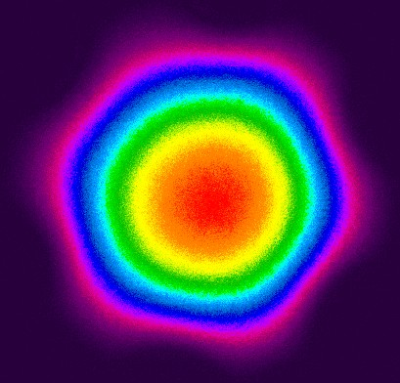 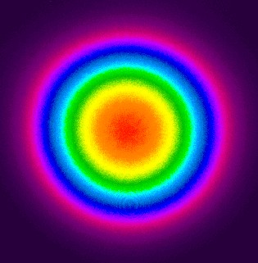

* See Opt. Express **22**, no. 9, 10735, 2014

** For b definition, see Opt. Exp. **21**, no. 23, 28597, 2013

## Output near field profile

*Output far field profile*

All specifications may be changed without notice

*123 avenue Albert Thomas - 87060 Limoges Cedex France* [*www.glophotonics.fr*](http://www.glophotonics.fr/)[*contact@glophotonics.fr*](mailto:contact@glophotonics.fr)