

***PMC-C-Green-40***

***Hollow-Core Fiber optimized for green spectral range.***

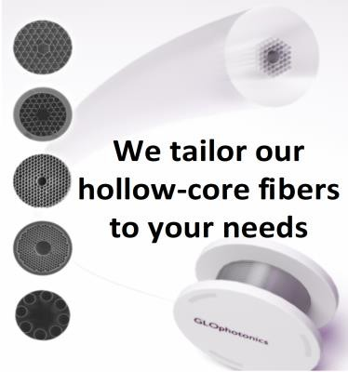

* *Nearly single mode guidance*
* *Low dispersion, low loss*
* *High power and energy handling*
* *Broad spectral coverage*

|  |  |
| --- | --- |
| **Physical Properties** | |
| Core contour | Hypocycloïd |
| Inner core diameter | 40 µm ± 2µm |
| Outer fiber diameter | 230 µm ± 1% |
| Fiber coating diameter | 400 µm ± 30µm |
|  | |
| **Optical Properties** | |
| Attenuation @ 515 nm | <30 dB/km |
| Attenuation @ 532 nm | <30 dB/km |
| Dispersion @ 532 nm | 1 ps/nm.km ± 0.5 |
| Mode Field Diameter (1/e²)  @ 532nm | 26 µm ± 1 µm |
| M² @ 532nm | <1,2 |
| N.A. | 0.014 ± 0.002 |

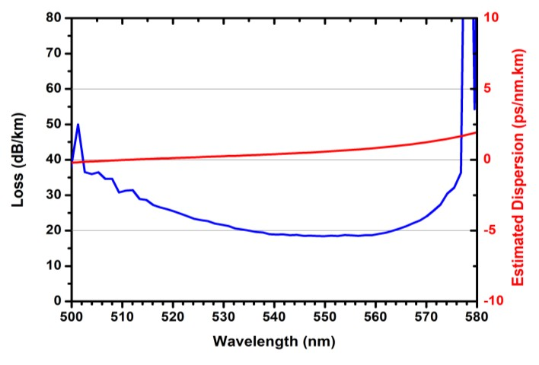

*Typical attenuation and dispersion*

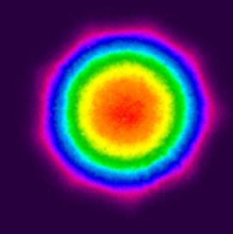 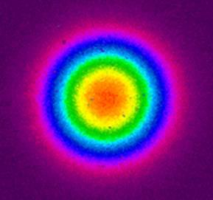

*Output near field profile*

*Output far field profile*

All specifications may be changed without notice

123 avenue Albert Thomas - 87060 Limoges Cedex France

[www.glophotonics.fr](http://www.glophotonics.fr/)

[contact@glophotonics.fr](mailto:contact@glophotonics.fr)