

*PMC-C-TiSa_Er-7C*

*Kagome Hollow-Core Fiber with optimized performance for 800nm and 1550nm. Ideal For Ti-Saph and Erbium based lasers.*

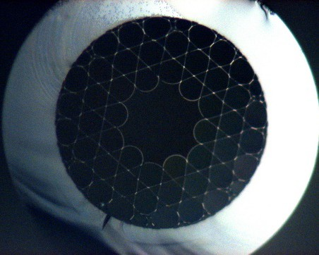

# *Broad Spectral Coverage*

* *Large Core Size*
* *Nearly Single Mode Guidance*
* *Low Dispersion*
* *Record–high laser damage threshold\**

## *Optical micrograph of fiber end facet*

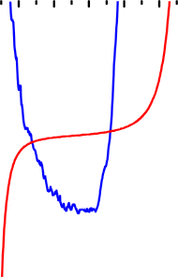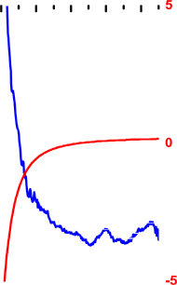

*Typical attenuation and dispersion*

*Physical Properties*

*Core contour*

*Hypocycloid with negative*

*curvature parameter b=1\**

*Inner Core*

*Diameter*

*63 µm ± 1*

*Outer Fiber Diameter*

*300 µm ± 1*

*Fiber Coating Layer*

*Primary polymer coating*

|  |  |
| --- | --- |
| *Optical Properties* | |
| *Center Wavelength* | *800 nm / 1600nm* |
| *Attenuation @ 800 nm /1550 nm* | *<80 dB/km ± 5* |
| *Dispersion @ 800 nm /1550 nm* | *1 ps/nm/km ± 0.5* |
| *Transmission band\*\**  *\*\*Attenuation lower than 100 dB/km*  *for the 1300-1750nm* | *>100 nm / >300nm* |
| *Mode Field Diameter (1/e²)* | *44 µm ± 1* |
| *3 dB bend loss radius* | *5 cm ± 2* |

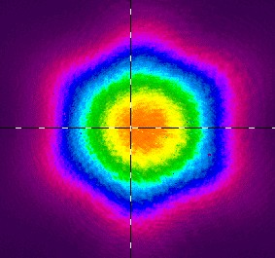

*Typical output near field profile @ 800 nm*

*\* See See CLEO STh4L.7, 2015*

*\*\* For b definition, see Opt. Exp. 21, no. 23, 28597, 2013*

*Glophotonics*

*Company Registration Number RCS Limoges 533 575 031 VAT Registration Number*

*FR 65533575031*

*Contact* [*www.glophotonics.fr*](http://www.glophotonics.fr/)[*contact@glophonics.fr*](mailto:contact@glophonics.fr)

*Address 123 avenue Albert Thomas 87060 Limoges Cedex*

*FRANCE*